OUTPUTS:
1.SENTIMENT DATA PREVIEW:

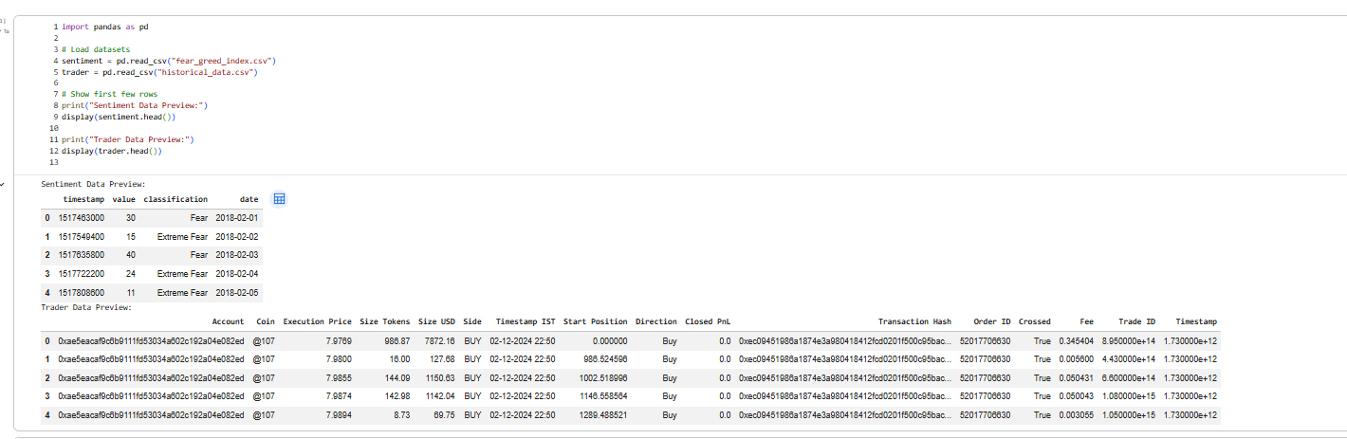

2. AVERAGE DAILY PNL BY MARKET SENTIMENT :
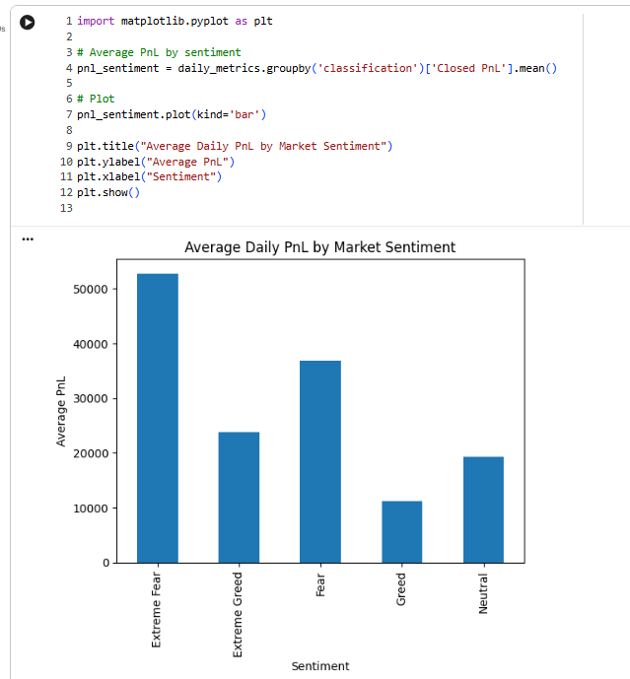

3.AVERAGE TRADE ACTIVITY BY MARKET SENTIMENT :
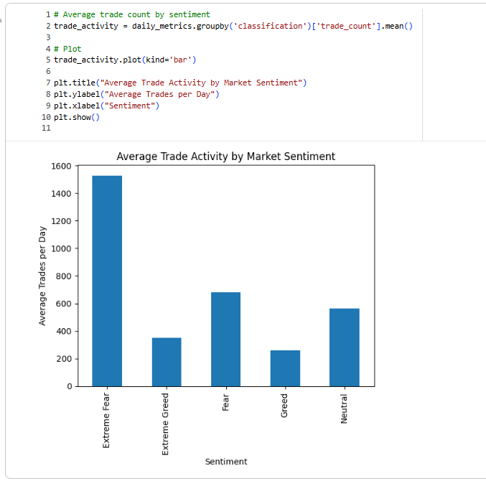

4. AVERAGE WIN RATE BY MARKET SENTIMENT :
